Feature article #49: ‘The flood of ‘86’ (written and researched by BK)
The record breaking floods of 1986 were easily the most impressive I’ve witnessed since living in the Kimberley which occurred 166km East of Broome. The flood was brought about by 400mm of rain over four days by a tropical low from Cyclone Hector. Further up, the floodwaters from Diamond Gorge, Christmas Creek, Margaret River, Liveringa, Fitzroy Crossing and Camballin all converged at Willare to create a monster flood of epic proportions.
In 1985, the Commonwealth Government funded a major upgrade of the Great Northern Highway to build an ‘’all weather’’ road across the flood plain west of the Willare Bridge on the Fitzroy River (Martuwarra). It was a Bi-Centennial project, and the road was raised to pass the estimated 100 year flood level of 1914. It was a massive project with the construction of two bridges (Cockatoo and Ski Lake) and the highway was nicknamed the ‘China Wall’ by the locals.
The very next year after the completion, there was a new record rainfall which washed over the highway taking all the bitumen. The deluge created an inland sea stretching back into the distant easterly horizon flooding the road astonishingly 13 km south/west from the Willare Bridge. The newly constructed bridges could not cope with this volume of water and that’s when things took a major turn for the worst.
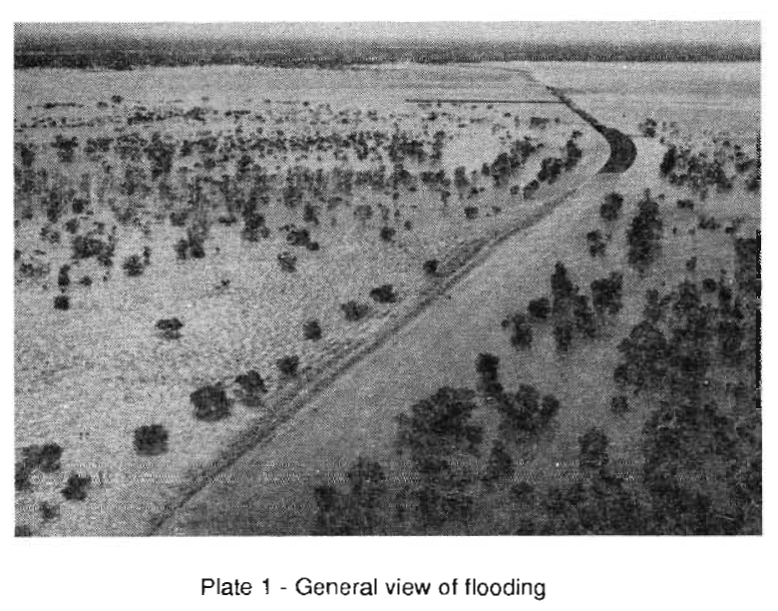
“Whoever designed it didn’t know this country. That road banked up the floodwaters right back from Willare to Fitzroy Crossing, hundreds of kilometres of river. The water covered areas I’ve never seen flooded before, even in a big flood. The Main Roads blasted a section of the ‘China Wall’ to release some of the pressure. I guess they were trying to minimise the damage to their newly completed $8.9 million section of the road. When that section of the wall was blown and the water started rushing through, it sucked the backwater out of all the waterholes upstream. Just as if somebody had put a hose in them and siphoned them dry. Not only that, but the sudden release of water also scoured a lot of our country. It caused big washaways along the bank of the creek which runs past Mt. Anderson homestead. When they dynamited at Willare, the rushing water just cut our creek banks to pieces”. (Extract taken from “Raparapa’’ published 1986 and this story related by Ivan Watson).
At that time, I remember travelling as far as possible to see the floodwaters for myself and was amazed that I could only reach about 13 kilometres back from the Willare Bridge before the road was impassable. In the distance I could see a stranded Road Train with floodwaters covering it up right up to the windscreen. The flood peaked on 28th Jan 1986 with a flow rate of 17,500 cubic metres per second. This was equivalent to emptying the Canning Dam in 90 minutes. One hundred and thirty metres of the ‘new highway’ was completely washed away. Much later when the flood waters finally subsided, the Cockatoo Bridge was left incongruously marooned with the complete highway washed away either side of it. There it stood starkly alone on the scoured mudflat, and to me it looked like an embarrassing ‘monument to madness’.
As I turned my car around to head back to Broome, I reflected on the awesome power of nature and the efforts to harness it which you do at your own peril. The cost of reconstruction repair of the highway came in at an extra $4.5 million.
I’ve also checked the rainfall figures from Broome Airport Met. office for January and February over the past 43 years that I have lived here and found that 2018 comes in first followed by 1997.
2018: January 945mm, February 614 for a total of 1559mm (61 inches). This was over double Melbourne’s annual rainfall of 660mm (26 inches) and the highest since records started in 1941.
1997: January 910mm, February 164 for a total of 1074mm (42inches)
1982: January 701mm, February 262 for a total of 963mm (38 inches)
1981: January 482mm, February 324 for a total of 806mm (32inches)
The most rain over January to April was the year 2000: January 230mm, February 380, March 493, April 247 for a total of for a total of 1350mm (53inches).
Interestingly, after the record rainfall in 2018 the following year in 2019: January recorded only 143mm and February 25mm for a total of 168mm.
(Black and white PHOTO FROM An article “Hydrological Hydraulic Investigation and floodway design at Willare Crossing of the Fitzroy River” by Harry Van Kleff and Jerome Goh).
INCREDIBLE 12 min VIDEO OF THE 1986 FLOODS https://www.facebook.com/watch/?v=1746816228774294

