WKFL Address – 6th Sept 2021 (Brian Kane)
2021 marks the 100th Anniversary of the West Kimberley Football League. This is a very significant milestone, as few country towns in rural WA can boast of such a long history.
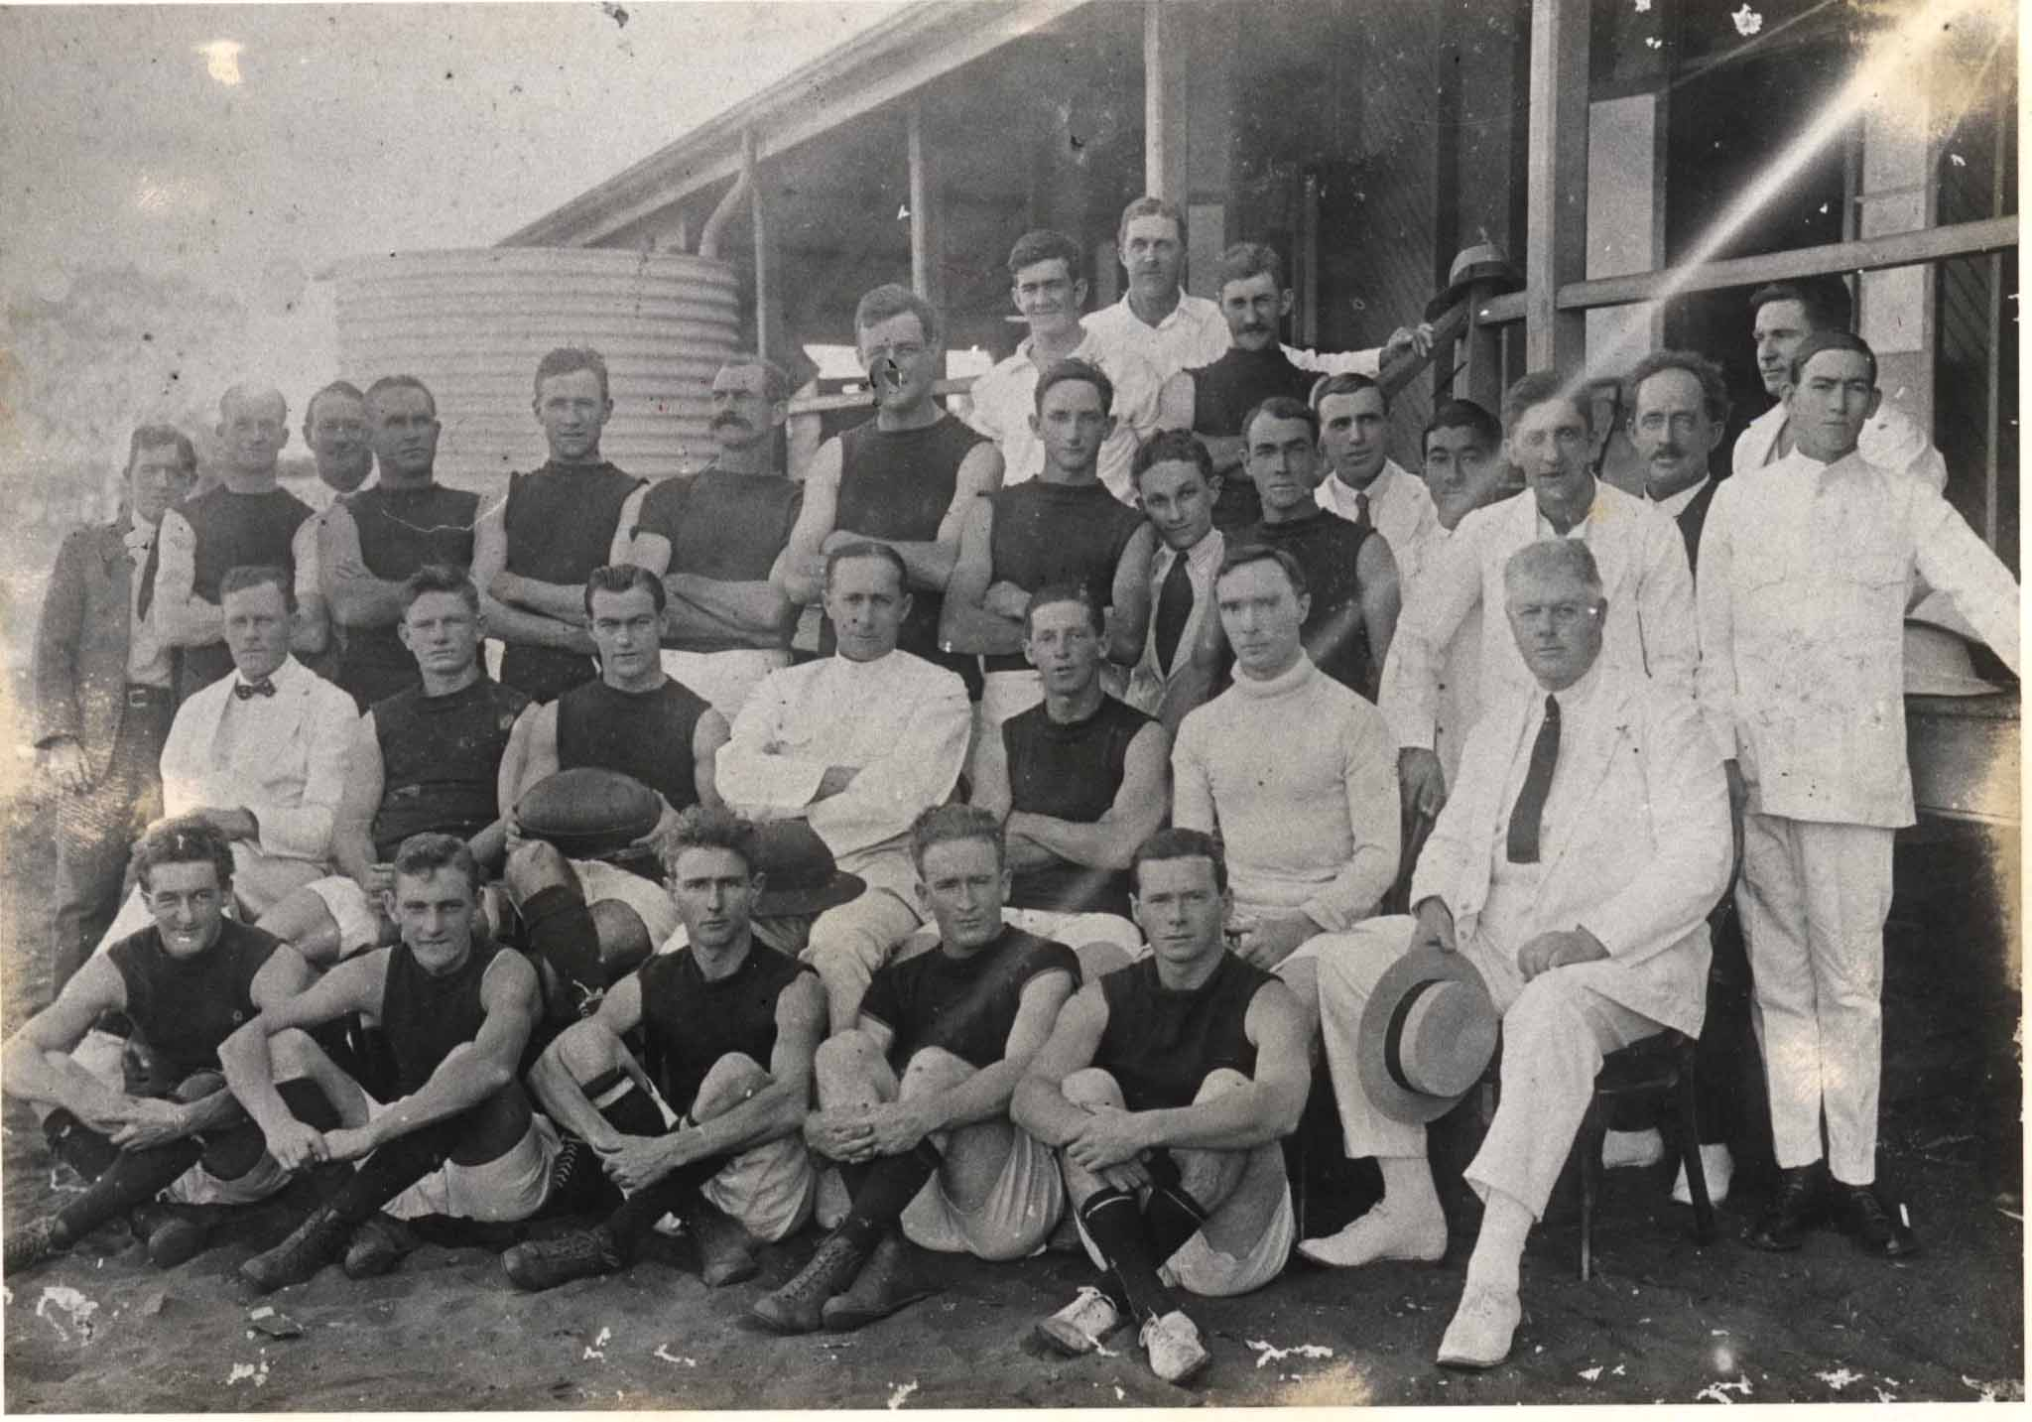
The first football scratch match in Broome was played on Sunday afternoon 29th May 1921, and afterwards an ongoing competition for the next three months was arranged between North and South Broome.
The First Grand Final was played on 21st August 1921. Here is a quote from the Nor West Echo Paper at the time: “Last Sunday saw the closing of Broome's first football season, when a large crowd attended. Intense excitement prevailed throughout the well fought game, the crowd on the "grandstand" swaying bodily with the flight of the ball, and yelling their throats sore in decrying opponents and urging their particular side to work. In the end, North Broome prevailed winning by 6 points: 6 goals 13 to South Broome 6 goals 7.
Over 40 years ago, I decided to leave the familiar surrounds of Melbourne in 1978 to travel around Australia. When I arrived in Broome after many long, gruelling hours on a Greyhound bus, I only intended to stop for 1 week. The highway was unsealed from Port Hedland back then, and when the bus rolled in at midnight on Friday the 13th October 1978 I was dropped off at the old DC3 Aeroplane Tourist Bureau. I said to the driver – “is this the centre of Broome?’’ because it seemed to be in the middle of nowhere. He told me to get back on the bus and then he dropped me off at the Continental Hotel affectionately known as ‘’The Conti’’. The only problem was that it was closed so I grabbed a few hours of sleep on the concrete bandstand out the back until sunrise.
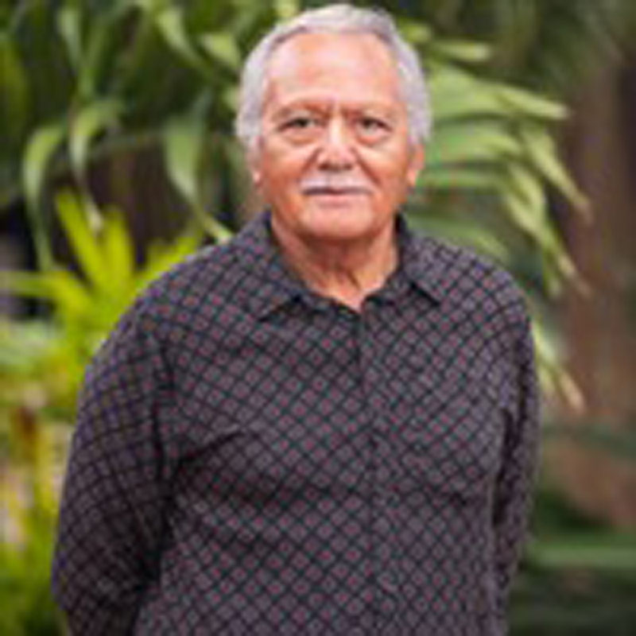
Greeting the new day, the first person I met in Broome was Phil Matsumoto. He owned Matso’s store just down the road from the Conti which was located on the corner of Anne St and Weld St. That was well before the building was moved to its present location on Hamersley St. I discovered that he was very involved in the sporting life of the town, devoting huge amounts of time to basketball and football organization as well as playing and umpiring. Years later he was made a Life Member of the WKFL and he is still very active today on the Shire Council over 40 years on.
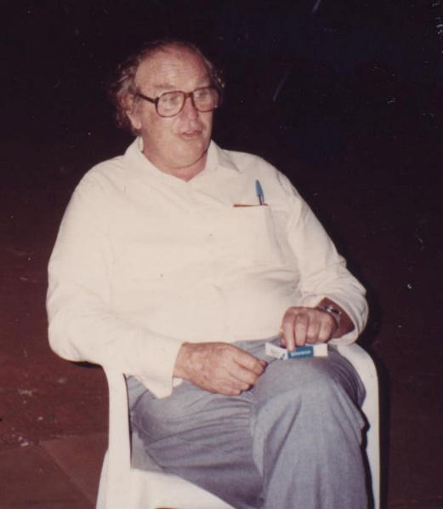
At the end of our conversation, he suggested that I walk a bit further down Weld St. to meet the Catholic Parish Priest of Broome, Fr. Michael McMahon or Father Mac as everyone knew him as. When I met him, I noticed that he had a broken arm and on further inquiry discovered it was from playing footy.
He invited me into the Presbytery to have a cup of tea. I said ‘’OK’’ and thought that I would see religious photos and a crucifix on the walls, but instead I found the table covered with footy flags and whistles and on the wall was a framed picture of the 1954 Footscray Premiership team (known as Western Bulldogs today).
Fr. Mac, with his unruly red hair and casual clothing was a larger than life character whom everybody loved. He was Parish Priest of Broome for 25 years and at BRACS the football oval rightly bears his name. From 1965 to 1968 there was no organised footy in town, but Fr. Mac resurrected the competition in 1969 and it has continued ever since. He was the first person to be made a life member of the WKFL.
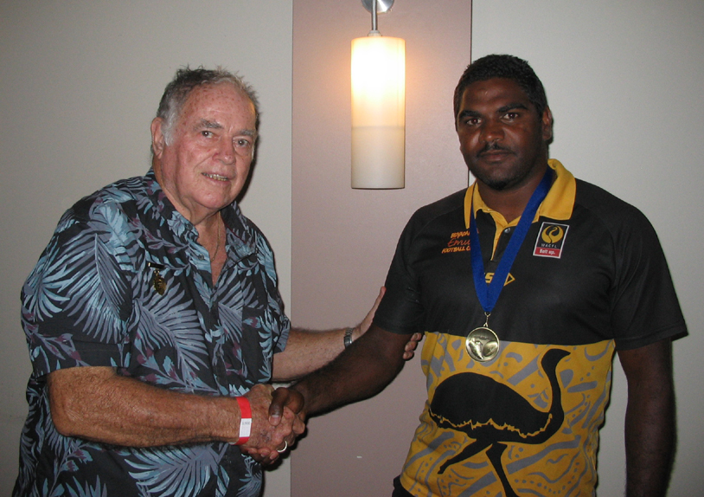Early in 1979, I attended the Annual General Meeting of the WKFL at the Broome Civic Centre chaired by Fr. Mac. I was amazed by one of the items on the agenda: Should football boots be made mandatory? I just assumed that everyone wore footy boots! Anyway, the motion was defeated, so players still had the choice to play barefooted it they wished.
It was at that meeting that I met Kevin Bullen. He and Fr. Mac were a great partnership, and Kevin had been President of the League in 1969, 1970, 1971 and 1978. Later, he was made a Life member of the WKFL and is still active today 52 years later. We are celebrating the 100th anniversary of the League this year, and incredibly, Kevin has been central to it for over half that time. The best and fairest trophy carries his name – THE BULLEN MEDAL.
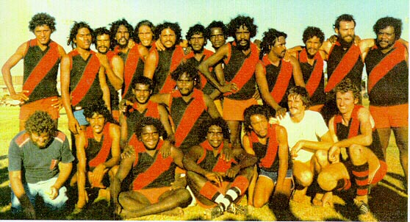If you are a newcomer to Broome, one of the best ways to establish friendships and to understand how the town operates is to join a sporting team. I did that in 1979 and was so elated to be part of Premiership team. Over 40 years later, I still have a shared bond of mateship with members of that Club. The following year, I decided to join the Beagle Bay Football Club. There were only 3 non indigenous players in the team – Olly Ryan, Dr. Felix from Brahms and me. I found myself on a steep learning curve – not about playing football – but sharing in the lives of people whose culture was completely different to mine.
In a tight game which went right down to the wire, Beagle Bay won the Premiership by 5 points, and it was the first time a Community team had won the flag. Local Member for the Kimberley, Ernie Bridge gave a stirring speech afterwards at the front bar of the Conti. Like the previous year, I still have a bond with those players which carries through today. Just recently, I ran into Nicky Williams who played in that team, and he came up and embraced me which brought tears to my eyes. This is what belonging to a sporting team can do when we accept each other as equals.
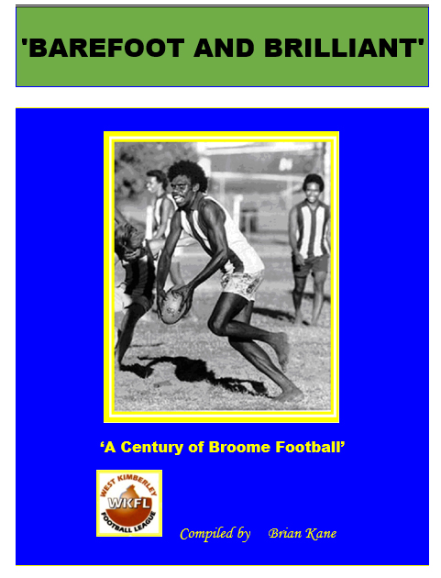
For many years I umpired junior and senior footy and it brought great satisfaction. I decided to write up the history of Broome Footy having discovered that there were few records held by the League at all prior to 1979. I began by spending many hours in the Battye Library in Perth pouring over the old Nor West Echo newspapers from 1921 to 1930 along with the photographs. From 1949 onwards I delved into the Nor West Times and also the locally produced Broome News Publications. It took me about 20 years to compile the history which also included many conversations with past players and officials.
I told a local editor Kevin Lawton of my endeavours, and that I was going to upload my research information to the internet calling it the History of Broome Football. He replied – ‘’That’s a pretty boring title’’ why don’t you name it ‘’Barefoot and Brilliant’’ and of course that’s what I did.
So, if you want to access the history of WKFL over the past 100 years, – just do a Google search and type in Barefoot and Brilliant. This site has been archived in the National Library in Canberra and in all major libraries throughout Australia through Pandora.
So in conclusion
- ON BEHALF OF THE WKFL WE WOULD LIKE TO THANK THE LEGION OF VOLUNTEERS WHO HAVE SUPPORTED AND CARRIED THE VARIOUS CLUBS SINCE THEIR INCEPTION.

- TO THE OFFICIALS, UMPIRES, THE ATTENDANTS AT THE GATE OVER THE YEARS, TO THOSE WHO MARK THE OVAL AND PROVIDE THE EQUIPMENT SO THAT THE GAMES HAPPEN, WE OFFER A HUGE THANK YOU

- TO THE PLAYERS WHO HAVE PROVIDED UNFORGETABLE HIGHLIGHTS AND ENTERTAINED US WITH THEIR DAZZLING SKILLS – WE SAY THANK YOU.
- 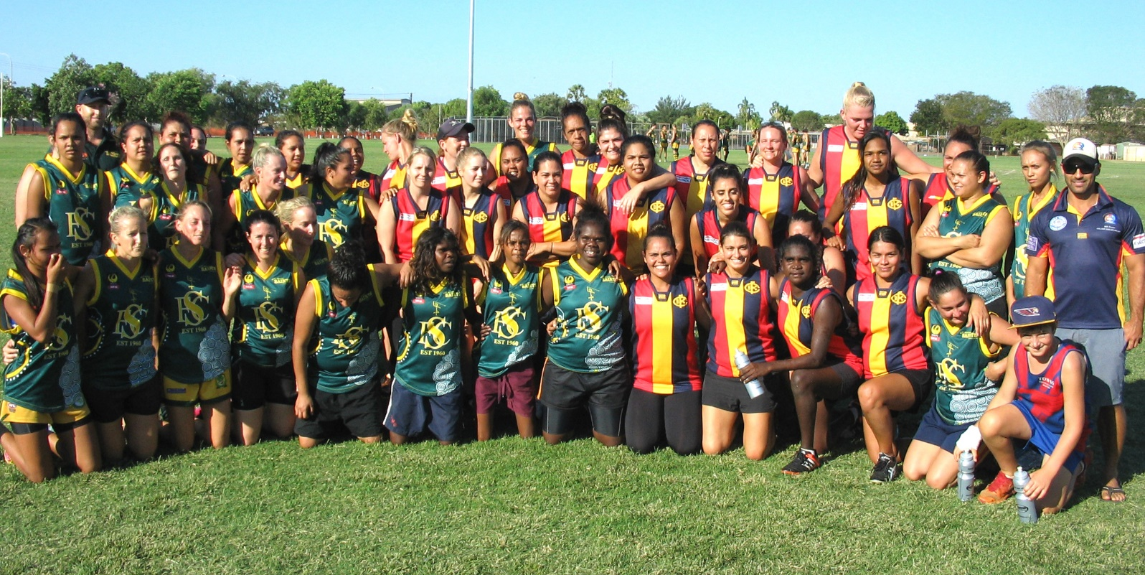WE APPLAUD THE INTRODUCTION OF THE WOMEN’S FOOTY COMPETITION IN 2015 AND THE SUBSEQUENT AWARD WINNERS AND PREMIERSHIP TEAMS SINCE THAT TIME.
- 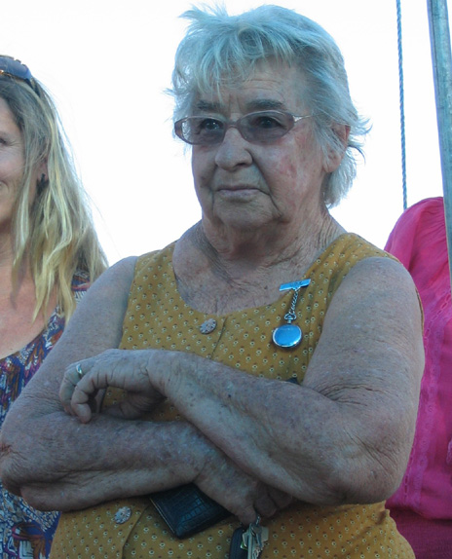WE SEND OUT A BIG THANKYOU TO THOSE WHO ORGANIZE AND OVERSEE THE JUNIOR FOOTBALL COMPETITION OVER THE YEARS: ESPECIALLY SINCE 1979, DISPLAYING SUCH COMMITMENT WITH PEOPLE LIKE ALMA MURRAY,THE PCYC, THE STAFF FROM OUR LOCAL SCHOOLS AND OF COURSE THE PARENTS.
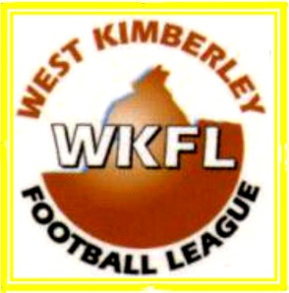
- ALL THOSE ASSOCIATED WITH THE WKFL OVER THE PAST 100 YEARS CAN BE JUSTLY PROUD OF WHAT HAS BEEN ACHIEVED. THIS HAS BEEN BORN OUT BY THE NUMBER OF PLAYERS WHO HAVE SUCCESSFULLY JOINED CLUBS IN THE AFL and WAFL COMPETITIONS IN PARTICULAR.

- TO OUR PRESENT CEO SAM, EUNICE, THE CURRENT BOARD MEMBERS AND THE MANY VOLUNTEERS, WE OFFER A HARDY THANK YOU FOR YOUR ONGOING CONTRIBUTION TO THE SPORTING LIFE OF BROOME.

- FINALLY, ON A PERSONAL NOTE, I’D LIKE TO THANK THE WKFL FOR GIVING ME THE PRIVILEGE OF ADDRESSING YOU TONIGHT AND WISH THOSE PARTICIPATING IN THIS YEAR’S GRAND FINAL THE BEST OF LUCK.

